RAJA BAHRAM SHAFIQ

01-135221-045

BS-IT (2A)

QUESTION 1:

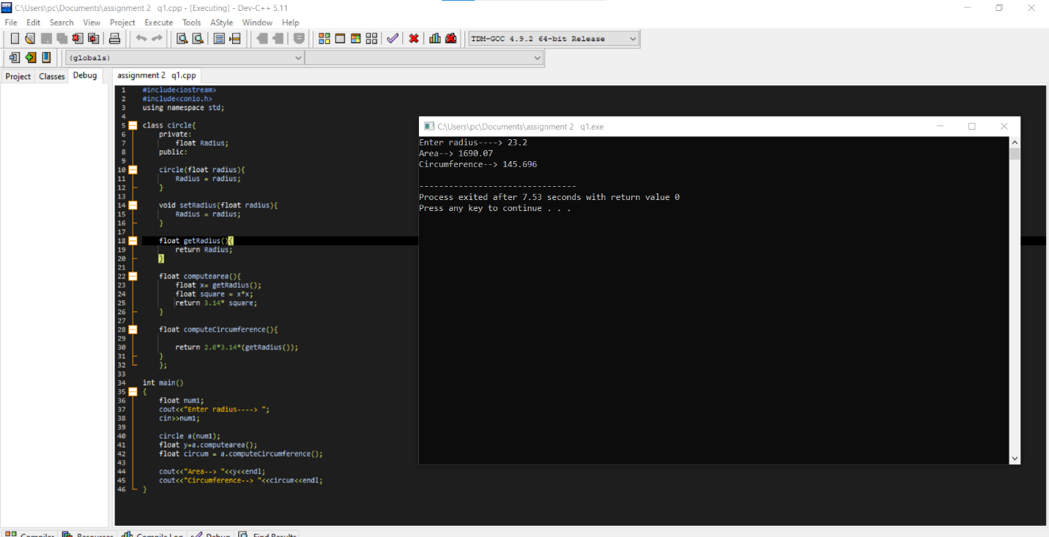

**QUESTION 2:**

